ENVIRONMENTAL MONITORING USING IOT

**PHASE 2:** INNOVATION

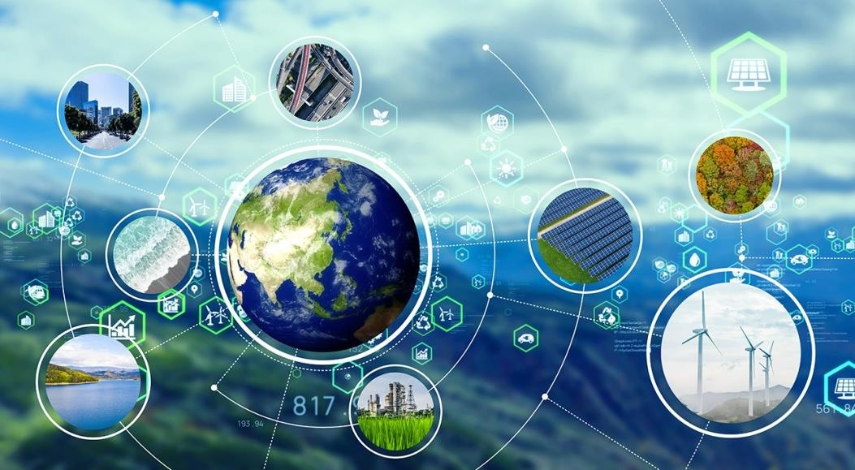

# Environmental monitoring

**INTRODUCTION :**

Environmental monitoring refers to the process of tracking and assessing various aspects of the natural environment to understand changes, trends, and potential impacts on ecosystems, human health, and the planet as a whole. It involves the collection, analysis, and interpretation of data related to air, water, soil, and other environmental factors.

Environmental monitoring is crucial for several reasons:

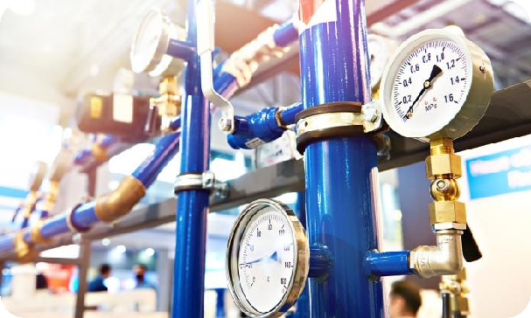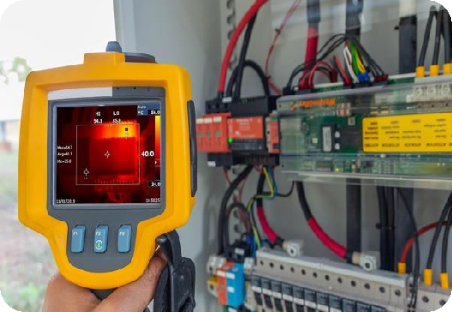

**Leak Detection Systems Techniques of Environmental Monitoring**

### Protecting Human Health :

Monitoring air and water quality helps identify pollutants and potential health risks, allowing for the implementation of measures to protect public health.

### Preserving Ecosystems :

By tracking changes in ecosystems, such as forests, wetlands, and oceans, environmental monitoring helps identify threats to biodiversity and habitat loss.

### Managing Natural Resources :

Monitoring soil quality and water resources aids in sustainable land and resource management, ensuring they are used wisely and conserved for future generations.

### Assessing Climate Change :

Monitoring temperature, greenhouse gas emissions, and other climate-related factors is vital for understanding and addressing climate change.

### Compliance with Regulations :

Many governments and organizations have established environmental regulations and standards that require regular monitoring to ensure compliance.

### Early Warning Systems:

Environmental monitoring can provide early warnings of natural disasters like floods, hurricanes, and earthquakes, allowing for timely responses to mitigate their impact.

# CIRCUIT DIAGRAM

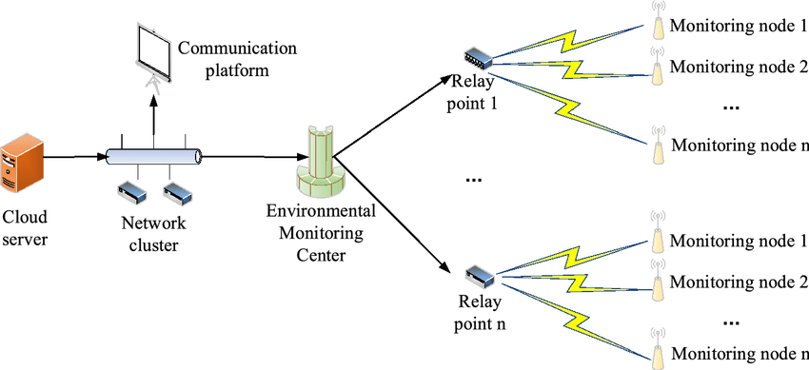

### Environmental monitoring typically involves the following key components:

1. **Data Collection :**

Sensors, instruments, and sampling methods are used to collect data on various environmental parameters, such as temperature, humidity, air quality, water quality, and biodiversity.

### Data Analysis :

Collected data are analyzed to detect trends, anomalies, and potential environmental issues. Statistical techniques and modeling may be used for in-depth analysis.

### Data Interpretation:

Interpreting the data involves understanding the implications of the findings, such as identifying the sources of pollution, assessing the health of ecosystems, or evaluating the impact of climate change.

### Reporting and Communication :

The results of environmental monitoring are often communicated to policymakers, the public, and relevant stakeholders through reports, data visualization, and public awareness campaigns.

### Regulatory Compliance :

In many cases, monitoring programs are established to ensure compliance with environmental laws and regulations. Data collected may be used to assess compliance and enforce corrective actions when necessary.

### Long-Term Monitoring:

Some environmental monitoring programs are conducted over extended periods to track changes and assess the effectiveness of environmental policies and mitigation measures.

## STEPS FOR FLOWCHART

**STEP 1** : Start

**STEP 2 :** Define Monitoring Objectives

**STEP 3** : Select Environmental Parameters to Monitor

**STEP4** :. Choose Monitoring Locations **STEP5** :. Deploy Monitoring Equipment **STEP6** :. Data Collection and Measurement

**STEP7** : Data Transmission (if remote monitoring)

**STEP8** : Data Storage and Management

**STEP9** : Data Analysis

**STEP10** : Interpretation and Reporting

**STEP11** : Decision-Making

**STEP12** : Implement Mitigation Measures (if necessary)

**STEP13** : Regulatory Compliance

**STEP14 :** Public Communication and Awareness

**STEP15 :** End

## FLOWCHART

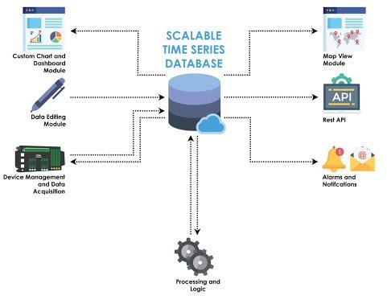

### CONCLUSION :

Environmental monitoring is a multidisciplinary field that involves collaboration between scientists, government agencies, environmental organizations, and the private sector. It plays a crucial role in addressing pressing environmental challenges and promoting the sustainable management of natural resources.